Chapter 7 A Revolutionary Generation

TRUE/FALSE

1. Most of the patriots in South Carolina lived in the Upcountry.
A. True
B. False

ANS: F
The Upcountry was the most divided.

PTS: 1 DIF: Knowledge REF: Chapter 7 Section 2
TOP: Pre American Revolution

2. Few conflicts during the American Revolution were fought in South Carolina.
A. True
B. False

ANS: F
South Carolina became the most intensely fought over state in the Nation.

PTS: 1 DIF: Comprehension REF: Chapter 7 Section 3
TOP: American Revolution

3. The Declaration of Independence was passed in July 1776.
A. True
B. False

ANS: T PTS: 1 DIF: Knowledge REF: Chapter 7 Section 2
TOP: American Revolution

4. The British believed they could conquer Georgia and South Carolina because there were so many loyalists who lived in those colonies.
A. True
B. False

ANS: T PTS: 1 DIF: Comprehension
REF: Chapter 7 Section 3 TOP: Pre American Revolution

5. South Carolina’s second constitution was written as a result of the colonies declaring their independence.
A. True
B. False

ANS: T PTS: 1 DIF: Comprehension
REF: Chapter 7 Section 2 TOP: South Carolina Constitution

6. The South Carolina House of Representatives, created under the Constitution of 1776, elected John Rutledge as the first chief executive and titled him “President.”
A. True
B. False

ANS: T PTS: 1 DIF: Knowledge REF: Chapter 7 Section 2
TOP: South Carolina Constitution

7. Sergeant William Jasper became a hero when he rescued the South Carolina flag during the Battle of Sullivan’s Island.
A. True
B. False

ANS: T PTS: 1 DIF: Knowledge REF: Chapter 7 Section 2
TOP: American Revolution

8. The American colonies were well represented in the British Parliament.
A. True
B. False

ANS: F
The American colonies did not have representation in the British Parliament.

PTS: 1 DIF: Application REF: Chapter 7 Section 1
TOP: Pre American Revolution

9. The Proclamation of 1763 kept settlers from claiming land in the Ohio and Tennessee River Valleys.
A. True
B. False

ANS: T PTS: 1 DIF: Comprehension
REF: Chapter 7 Section 1 TOP: Pre American Revolution

10. The Stamp Act was an example of an indirect tax.
A. True
B. False

ANS: F
The Stamp Act was an example of a direct tax.

PTS: 1 DIF: Comprehension REF: Chapter 7 Section 1
TOP: Pre American Revolution

11. The port of Boston was closed as punishment for the Boston Tea Party.
A. True
B. False

ANS: T PTS: 1 DIF: Knowledge REF: Chapter 7 Section 2
TOP: Pre American Revolution

12. South Carolina sent seven representatives to Philadelphia to attend the Second Continental Congress.
A. True
B. False

ANS: F
South Carolina sent four representatives to Philadelphia to attend the Second Continental Congress.

PTS: 1 DIF: Knowledge REF: Chapter 7 Section 1
TOP: Declaration of Independence

13. The Sugar Act had the greatest impact on all the British colonies.
A. True
B. False

ANS: F
The Sugar Act was an indirect tax that had met little opposition.

PTS: 1 DIF: Application REF: Chapter 7 Section 1
TOP: Pre American Revolution

14. In the Constitutional Convention that met in Philadelphia, large states favored representation in the national Congress based on population.
A. True
B. False

ANS: T PTS: 1 DIF: Comprehension
REF: Chapter 7 Section 4 TOP: U.S. Constitution

15. South Carolina’s representatives at the Constitutional Convention supported the “Three-Fifths Compromise.”
A. True
B. False

ANS: F
South Carolina’s representatives at the Constitutional Convention did not support the “Three-Fifths Compromise.”

PTS: 1 DIF: Knowledge REF: Chapter 7 Section 4
TOP: Constitutional Convention

16. The people of South Carolina immediately approved the new United States Constitution.
A. True
B. False

ANS: F
The people of South Carolina at first were divided in their support of the new United States Constitution.

PTS: 1 DIF: Knowledge REF: Chapter 7 Section 4
TOP: U.S. Constitution

MULTIPLE CHOICE

1. What treaty called for a position of neutrality between the loyalists and the patriots in the Upcountry?
A. | the Treaty of Augusta
B. | the Treaty of Ninety-Six
C. | the Treaty of Orangeburg
D. | the Treaty of Yorktown

ANS: B PTS: 1 DIF: Knowledge REF: Chapter 7 Section 2
TOP: American Revolution

2. What was a power given to the House of Representatives of South Carolina under the 1776 constitution?
A. | the power to appoint legislators
B. | the power to declare war
C. | the power to make pardons
D. | the power to elect a chief executive whom they called a president

ANS: D PTS: 1 DIF: Comprehension
REF: Chapter 7 Section 2 TOP: South Carolina Constitution

3. Who chose South Carolina’s president under the constitution of 1776?
A. | the governor
B. | all the people
C. | all males over 21
D. | members of the legislature

ANS: D PTS: 1 DIF: Knowledge REF: Chapter 7 Section 2
TOP: South Carolina Constitution

4. Who benefited from the Lowcountry’s having the largest number of members in the lower house of the legislature after the war?
A. | the farmers
B. | the loyalists
C. | the manufacturers
D. | the patriots

ANS: D PTS: 1 DIF: Analysis REF: Chapter 7 Section 4
TOP: South Carolina Constitution

5. Why did the British’s plan to take Sullivan’s Island fail?
A. | A tropical storm made storming the island impossible.
B. | The British cannonballs were not large enough to destroy the fort.
C. | The colonists discovered their plan and were able to defend against it.
D. | The palmetto logs from which the fort was made absorbed the cannonballs.

ANS: D PTS: 1 DIF: Comprehension
REF: Chapter 7 Section 2 TOP: American Revolution

6. Which statement BEST explains how the actions of Banastre Tarleton “inspired” the patriots?
A. | Tarleton was a brave and courageous fighter.
B. | Tarleton was a cruel leader who slaughtered men without reason.
C. | Tarleton was an immigrant who came to America and became a successful businessman.
D. | Tarleton was a brilliant strategist whose plans were responsible for a number of important victories.

ANS: B PTS: 1 DIF: Analysis REF: Chapter 7 Section 3
TOP: American Revolution

7. What battle was called the “turning point of the American Revolution in the South”?
A. | Camden
B. | Cowpens
C. | Kings Mountain
D. | Moore’s Creek Bridge

ANS: C PTS: 1 DIF: Knowledge REF: Chapter 7 Section 3
TOP: American Revolution

8. What was the significance of the Battle at Cowpens?
A. | It was the turning point of the war.
B. | The American forces won their first victory.
C. | It was the last major battle in South Carolina.
D. | Lord Cornwallis left South Carolina after the battle.

ANS: D PTS: 1 DIF: Comprehension
REF: Chapter 7 Section 3 TOP: American Revolution

9. Where was the last major battle of the American Revolution in South Carolina fought?
A. | Camden
B. | Cowpens
C. | Eutaw Springs
D. | Hobkirk’s Hill

ANS: C PTS: 1 DIF: Knowledge REF: Chapter 7 Section 3
TOP: American Revolution

10. What sacrifice did Henry Laurens make for the independence of the American colonies?
A. | He was killed in battle.
B. | He served 15 months in prison for his attempts to get aid for the colonies.
C. | He gave thousands of dollars of his own money to support colonial independence.
D. | He gave up his position in the Second Continental Congress to serve in the military.

ANS: B PTS: 1 DIF: Comprehension
REF: Chapter 7 Section 4 TOP: American Revolution

11. Who would control the state in the South Carolina Constitution written in 1778?
A. | Upcountry
B. | Lowcountry
C. | Middle Country
D. | equal power among all voters

ANS: B PTS: 1 DIF: Comprehension
REF: Chapter 7 Section 2 TOP: South Carolina Constitution

12. How did the British reward slaves who served them in the American Revolution?
A. | They paid them well.
B. | They gave them medals.
C. | They gave them their freedom.
D. | They took them to England to live after the war.

ANS: C PTS: 1 DIF: Comprehension
REF: Chapter 7 Section 3 TOP: American Revolution

Declaration of Independence

When, in the Course of human events, it becomes necessary for one people to dissolve the political bands which have connected them with another, and to assume, among the Powers of the earth, the separate and equal station to which the Laws of Nature and of Nature’s God entitle them, a decent respect to the opinions of mankind requires that they should declare the causes which impel them to the separation.

We hold these truths to be self-evident, that all men are created equal, that they are endowed by their Creator with certain inalienable Rights, that among these are Life, liberty, and the pursuit of Happiness. That to secure these rights, Governments are instituted among men, deriving their just powers from the consent of the governed. That whenever any Form of Government becomes destructive of these ends, it is the Right of the People to alter or abolish it and to institute new Government, laying its foundation on such principles and organizing its powers in such form, as to them shall seem most likely to effect their Safety and Happiness.

13. According to the first paragraph, what was the purpose of the Declaration of Independence?
A. | to declare the actual separation from Great Britain
B. | to declare the reasons to separate from Great Britain
C. | to show how the colonies had been disrespected by Great Britain
D. | to propose a policy of “separate but equal” treatment by Great Britain

ANS: B PTS: 1 DIF: Comprehension
REF: Chapter 7 Section 2 TOP: American Revolution

14. According to the Declaration of Independence, which was NOT an inalienable right?
A. | liberty
B. | life
C. | happiness
D. | religion

ANS: D PTS: 1 DIF: Comprehension
REF: Chapter 7 Section 2 TOP: American Revolution

15. According to the Declaration of Independence, how does government get its power?
A. | from the creator
B. | from the governor
C. | from the king
D. | from the people

ANS: D PTS: 1 DIF: Comprehension
REF: Chapter 7 Section 2 TOP: American Revolution

16. According to the Declaration of Independence, when is it permissible for people to change the government?
A. | when the government needs money
B. | when the government has a new leader
C. | when the government takes away rights
D. | when the government becomes outdated

ANS: C PTS: 1 DIF: Comprehension
REF: Chapter 7 Section 2 TOP: American Revolution

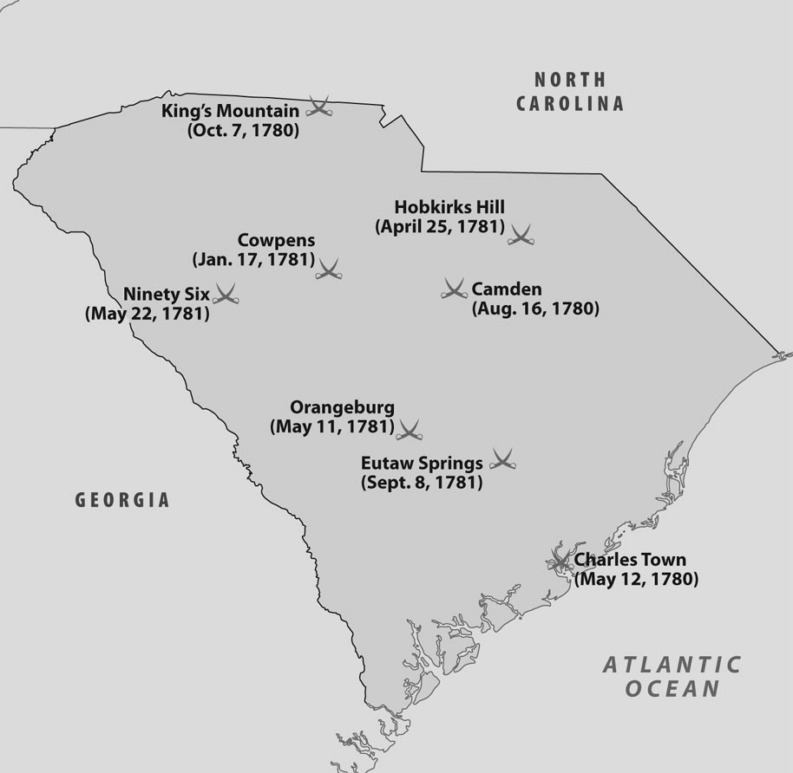

17. According to the map, what was the earliest Revolutionary War battle fought in South Carolina?
A. | Camden
B. | Charles Town
C. | King’s Mountain
D. | Orangeburg

ANS: B PTS: 1 DIF: Application REF: Chapter 7 Section 3
TOP: American Revolution

18. According to the map, what was the last Revolutionary War battle fought in South Carolina?
A. | Cowpens
B. | Eutaw Springs
C. | Ninety Six
D. | Orangeburg

ANS: B PTS: 1 DIF: Application REF: Chapter 7 Section 3
TOP: American Revolution

19. What resulted from Parliament’s lack of understanding of the needs of the colonists?
A. | a study to prioritize the needs in the colonies
B. | sending more British representatives to America
C. | the beginnings of self-government in the colonies
D. | having Parliament work more closely with colonial assemblies

ANS: C PTS: 1 DIF: Analysis REF: Chapter 7 Section 1
TOP: Pre American Revolution

20. Where were most of the conflicting land claims between the French and the British?
A. | in the Ohio Valley
B. | along the Gulf Coast
C. | along the Mississippi River
D. | in the New England Colonies

ANS: A PTS: 1 DIF: Comprehension
REF: Chapter 7 Section 2 TOP: French/British Colonial Rivalry

21. Which statement BEST describes how the French and Indian War led to the American Revolution?
A. | Great Britain gained control of Canada and tried to use Canada’s tax structure on the thirteen colonies.
B. | France lost the Louisiana Territory, and the Southern Colonies argued with Great Britain over claims to the newly acquired land.
C. | France, which was bitter over losing the war to Great Britain, incited rebellion in the colonies and urged Spain to move into the territories of the British colonies.
D. | Great Britain was heavily in debt after the war and tried to recover monies by taxing the colonies on the premise that the war had been necessary to protect the colonies from the French.

ANS: D PTS: 1 DIF: Analysis REF: Chapter 7 Section 1
TOP: Pre American Revolution

22. What were the Townshend Acts?
A. | The British put taxes on imported goods such as tea and glass.
B. | The British put taxes on hotels and other lodging accommodations.
C. | The British put taxes on newspapers, magazines, and official licenses.
D. | The British put taxes on all goods not exported or imported on British ships.

ANS: A PTS: 1 DIF: Comprehension
REF: Chapter 7 Section 1 TOP: Pre American Revolution

23. What was the purpose of the Boston Tea Party?
A. | to protest the Intolerable Acts
B. | to protest the Sugar Act
C. | to protest the Tea Act
D. | to protest the Townshend Acts

ANS: C PTS: 1 DIF: Comprehension
REF: Chapter 7 Section 1 TOP: Pre American Revolution

24. What event convinced South Carolina to send representatives to the First Continental Congress?
A. | passage of the Currency Act
B. | passage of the Intolerable Acts
C. | passage of the Navigation Acts
D. | passage of the Stamp Act

ANS: B PTS: 1 DIF: Comprehension
REF: Chapter 7 Section 1 TOP: Pre American Revolution

25. How did South Carolinians help Bostonians after the passage of the Intolerable Acts?
A. | They sent money.
B. | They sent food and aid.
C. | They sent ships.
D. | They sent troops.

ANS: B PTS: 1 DIF: Comprehension
REF: Chapter 7 Section 1 TOP: Pre American Revolution

26. Which man did NOT represent South Carolina at the First Continental Congress in Philadelphia?
A. | William Bull
B. | Christopher Gadsden
C. | Thomas Lynch
D. | Edward Rutledge

ANS: A PTS: 1 DIF: Knowledge REF: Chapter 7 Section 3
TOP: Pre American Revolution

27. Which two factions emerged in South Carolina before the beginning of the American Revolution?
A. | Patriots and Loyalists
B. | Democrats and Republicans
C. | Upcountry and Lowcountry
D. | Abolitionists and Segregationists

ANS: A PTS: 1 DIF: Comprehension
REF: Chapter 7 Section 1 TOP: Pre American Revolution

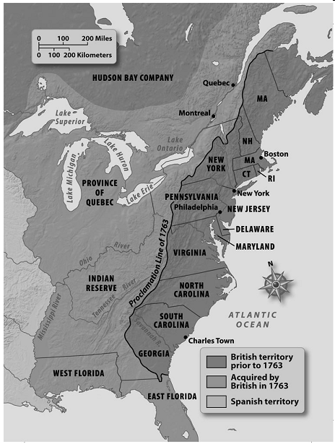

28. According to the map, what country controlled the land west of the Mississippi River?
A. | France
B. | Great Britain
C. | Spain
D. | United States

ANS: C PTS: 1 DIF: Application REF: Chapter 7 Section 1
TOP: Pre American Revolution

29. According to the map, what land did the British acquire in 1763?
A. | all of Canada
B. | the thirteen colonies
C. | land between the Mississippi River and the Atlantic Ocean
D. | land between the Proclamation Line and the Mississippi River

ANS: D PTS: 1 DIF: Application REF: Chapter 7 Section 1
TOP: Pre American Revolution

30. South Carolina was in conflict with King George III because
A. | the state refused to pay any of his taxes.
B. | the state established an army to oppose the king.
C. | the state legislature wanted to arrest John Wilkes.
D. | the state contributed to John Wilkes defense fund.

ANS: D PTS: 1 DIF: Analysis REF: Chapter 7 Section 1
TOP: Pre American Revolution

31. What was the British response to the boycott on British goods by the colonists?
A. | Great Britain increased prices on goods.
B. | Great Britain lost profits and raised taxes even more.
C. | Great Britain repealed the Townshend Act.
D. | Great Britain sent troops to punish the colonists.

ANS: C PTS: 1 DIF: Comprehension
REF: Chapter 7 Section 1 TOP: Pre American Revolution

32. In what city did the First Continental Congress meet on September 1774?
A. | Philadelphia
B. | Washington, D.C.
C. | New York
D. | Boston

ANS: A PTS: 1 DIF: Knowledge REF: Chapter 7 Section 1
TOP: Pre American Revolution

33. The most famous symbol of American defiance of British rule was
A. | passing the Townshend Act.
B. | the First Continental Congress.
C. | the Boston Tea Party.
D. | the boycott of British goods.

ANS: C PTS: 1 DIF: Analysis REF: Chapter 7 Section 1
TOP: Post American Revolution

34. How did the American Revolution change South Carolina’s economy?
A. | The demand for rice as a food product grew.
B. | Planters and merchants had to find new markets.
C. | The state’s staple crops were given large bonuses.
D. | The settlers could now expand their plantations by moving into western lands.

ANS: B PTS: 1 DIF: Comprehension
REF: Chapter 7 Section 4 TOP: Post American Revolution

35. What resolution eased the tensions between the Upcountry and the Lowcountry?
A. | The legislature agreed to build a new capital in the middle of the state.
B. | The Upcountry was given equal representation in the state legislature.
C. | The Lowcountry agreed to support needed internal improvements in the Upcountry.
D. | The loyalists in the Upcountry were pardoned for their role in the American Revolution and had their land returned.

ANS: A PTS: 1 DIF: Application REF: Chapter 7 Section 4
TOP: Post American Revolution

36. When South Carolina’s capital was moved from Charles Town, what name was given to the new seat of state government?
A. | Charleston
B. | Columbia
C. | Florence
D. | Rock Hill

ANS: B PTS: 1 DIF: Knowledge REF: Chapter 7 Section 4
TOP: Post American Revolution

37. When Charles Town was incorporated, what was its new name?
A. | Charleston
B. | Columbia
C. | Florence
D. | Rock Hill

ANS: A PTS: 1 DIF: Knowledge REF: Chapter 7 Section 4
TOP: Post American Revolution

38. What was the first constitution of the United States called?
A. | the Articles of Confederation
B. | the Bill of Rights
C. | the United States Constitution
D. | the Mayflower Compact

ANS: A PTS: 1 DIF: Knowledge REF: Chapter 7 Section 2
TOP: Articles of Confederation

39. What was a major weakness of the Articles of Confederation?
A. | The federal government had little power.
B. | The Articles of Confederation could be revised.
C. | The federal government represented all 13 states.
D. | The Articles of Confederation was not ratified by all the states.

ANS: A PTS: 1 DIF: Comprehension
REF: Chapter 7 Section 2 TOP: Articles of Confederation

40. Which man did NOT represent South Carolina at the Constitutional Convention in Philadelphia?
A. | Pierce Butler
B. | James Madison
C. | Charles Pinckney
D. | John Rutledge

ANS: B PTS: 1 DIF: Knowledge REF: Chapter 7 Section 4
TOP: Constitutional Convention

41. What did the delegates to the Philadelphia Convention in 1787 decide to do?
A. | elect a president
B. | establish a court system
C. | develop at new government
D. | revise the Articles of Confederation

ANS: C PTS: 1 DIF: Comprehension
REF: Chapter 7 Section 4 TOP: Constitutional Convention

42. What idea for the federal government was supported by the South Carolina delegates at the Philadelphia Convention?
A. | a weak president
B. | legislative power to tax
C. | legislative power to raise an army
D. | a presidential term of office of four years

ANS: B PTS: 1 DIF: Comprehension
REF: Chapter 7 Section 4 TOP: Constitutional Convention

43. What compromise settled the issue of how representation would be allocated in the national Congress?
A. | the Constitutional Compromise
B. | the Great Compromise
C. | the Missouri Compromise
D. | the Three-Fifths Compromise

ANS: B PTS: 1 DIF: Application REF: Chapter 7 Section 4
TOP: U.S. Constitution

44. What reason was given by the Antifederalists to oppose the U.S. Constitution?
A. | They feared a stronger document might interfere with individual liberties.
B. | The document was not written by people supporting all aspects of society.
C. | The document gave the northern states more power than the southern states.
D. | The document did not solve the problems identified under the Articles of Confederation.

ANS: A PTS: 1 DIF: Comprehension
REF: Chapter 7 Section 4 TOP: U.S. Constitution

45. Which South Carolinian was a Federalist?
A. | Aedanus Burke
B. | Rawlins Lowndes
C. | Charles Pinckney
D. | Roger Sherman

ANS: C PTS: 1 DIF: Application REF: Chapter 7 Section 4
TOP: U.S. Constitution

Preamble to the United States Constitution

We, the People of the United States, in order to form a more perfect Union, establish Justice, insure domestic Tranquility, provide for the common defense, promote the general Welfare, and secure the Blessings of Liberty to ourselves and our Posterity, do ordain and establish this Constitution for the United States of America.

46. According to the Preamble, how many reasons are given for the creation of the U.S. Constitution?
A. | 2
B. | 4
C. | 6
D. | 8

ANS: C PTS: 1 DIF: Comprehension
REF: Chapter 7 Section 4 TOP: U.S. Constitution

47. What might the founding fathers have meant by the phrase “to form a more perfect Union”?
A. | to form a Union in which all men were created equal
B. | to form a Union that other nations would respect throughout the world
C. | to form a Union that would not be as overbearing as that of Great Britain
D. | to form a Union that was better than that created by the Articles of Confederation

ANS: D PTS: 1 DIF: Comprehension
REF: Chapter 7 Section 4 TOP: U.S. Constitution

48. After the ratification of the U.S. Constitution, why did South Carolinians in the Upcountry want a new state constitution for South Carolina?
A. | to locate the state capital in their section of the state
B. | to change some of the provisions of the United States Constitution
C. | to gain equal representation in the South Carolina General Assembly
D. | to make a state constitution that was better than the national constitution

ANS: C PTS: 1 DIF: Analysis REF: Chapter 7 Section 4
TOP: South Carolina Constitution

49. Which provision was included in the South Carolina Constitution of 1790?
A. | the creation of a state church
B. | the elimination of the voting rights of blacks
C. | the increase in the property requirements to vote
D. | the establishment of age requirements to hold elective office

ANS: C PTS: 1 DIF: Comprehension
REF: Chapter 7 Section 4 TOP: South Carolina Constitution

50. Which statement BEST illustrates why the legislature was so powerful in South Carolina in 1790?
A. | The legislature made the laws for the state.
B. | The legislature chose almost all the state officials.
C. | The members of the legislature were chosen for life.
D. | The legislature was made up of the most powerful men in the state.

ANS: B PTS: 1 DIF: Analysis REF: Chapter 7 Section 4
TOP: South Carolina Constitution

51. What was the motive behind the Three-Fifths Compromise, which counted slaves as only three-fifths of a person for official population counts?
A. | Northern states wanted to prevent southern states from having control of the U.S. Senate.
B. | Northern states wanted slaves to be counted in the population so they could gain the rights of citizens.
C. | Northern states wanted to prevent southern states from having control of the House of Representatives.
D. | Southern states did not want to count slaves as citizens because they considered slaves as property not citizens.

ANS: C PTS: 1 DIF: Analysis REF: Chapter 7 Section 4
TOP: U.S. Constitution

52. What motive was behind the Great Compromise?
A. | Having membership in Congress based on proportional representation would favor states with small populations.
B. | Having membership in Congress based on proportional representation would favor states with large populations.
C. | The Great Compromise allowed the nation to have a president as chief executive but not one selected directly by the voters.
D. | The Great Compromise allowed the nation to have a national court system, but the Congress had the power to appoint judges.

ANS: B PTS: 1 DIF: Analysis REF: Chapter 7 Section 4
TOP: U.S. Constitution

COMPLETION

1. The war between the loyalists and patriots that existed in South Carolina was known as a(n) ____________________ war.

ANS: civil

PTS: 1 DIF: Comprehension REF: Chapter 7 Section 2
TOP: American Revolution

2. Most of the patriots in South Carolina lived in the ____________________.

ANS: Lowcountry

PTS: 1 DIF: Knowledge REF: Chapter 7 Section 1
TOP: American Revolution

3. As a lasting remembrance of the battle on Sullivan’s Island, a(n) ____________________ was added to the fort’s flag.

ANS: palmetto tree

PTS: 1 DIF: Knowledge REF: Chapter 7 Section 2
TOP: American Revolution

4. _________________________ was considered a hero at the battle of Sullivan’s Island because he went over the wall to rescue the fort’s flag, which had been knocked down by a British cannonball.

ANS: Sgt. William Jasper

PTS: 1 DIF: Knowledge REF: Chapter 7 Section 2
TOP: American Revolution

5. Francis Marion and Thomas Sumter used ____________________ warfare, a type of fighting in which small groups of soldiers harass or launch surprise attacks on the enemy and then suddenly disappear.

ANS: guerrilla

PTS: 1 DIF: Comprehension REF: Chapter 7 Section 3
TOP: American Revolution

6. Francis Marion was given the name ____________________ to commemorate his style of fighting.

ANS: Swamp Fox

PTS: 1 DIF: Knowledge REF: Chapter 7 Section 3
TOP: American Revolution

7. ____________________ was the governor of South Carolina during the American Revolution.

ANS: John Rutledge

PTS: 1 DIF: Knowledge REF: Chapter 7 Section 2
TOP: American Revolution

8. The Tea Act gave the ______________________________ a monopoly on the tea trade in the colonies.

ANS: East India Company

PTS: 1 DIF: Knowledge REF: Chapter 7 Section 1
TOP: Pre American Revolution

9. When only one company has the right to sell a product, the company is said to have a(n) ____________________.

ANS: monopoly

PTS: 1 DIF: Comprehension REF: Chapter 7 Section 1
TOP: Pre American Revolution

10. The Intolerable Acts were designed to punish the colony of ____________________.

ANS: Massachusetts

PTS: 1 DIF: Knowledge REF: Chapter 7 Section 1
TOP: Pre American Revolution

11. John Rutledge and Christopher Gadsden were two of South Carolina’s five representatives to the ______________________________.

ANS: First Continental Congress

PTS: 1 DIF: Knowledge REF: Chapter 7 Section 1
TOP: Pre American Revolution

12. ____________________ served as president of the First Continental Congress for a brief period.

ANS: Henry Middleton

PTS: 1 DIF: Knowledge REF: Chapter 7 Section 1
TOP: Pre American Revolution

13. Of South Carolina’s five representatives to the First Continental Congress, only _________________________ was an early advocate of Great Britain.

ANS: Christopher Gadsden

PTS: 1 DIF: Application REF: Chapter 7 Section 1
TOP: Pre American Revolution

14. Alexander Hamilton succeeded in getting the ____________________established, owned partly by government and partly by private individuals.

ANS: United States Bank

PTS: 1 DIF: Comprehension REF: Chapter 7 Section 4
TOP: Post American Revolution

15. Thomas Jefferson favored a(n) _________________________ of the Constitution, which said if the Constitution did not specifically give Congress the power to do something, it could not be done.

ANS: strict construction

PTS: 1 DIF: Comprehension REF: Chapter 7 Section 4
TOP: U.S. Constitution

16. The most important power of the new United States Constitution was to ______________ _______________.

ANS: levy (collect) taxes

PTS: 1 DIF: Application REF: Chapter 7 Section 4
TOP: U.S. Constitution

ESSAY

1. Describe conditions in South Carolina after the Revolutionary War.

ANS:
Answers will vary, but may include
-many Loyalists left the state
-fewer slaves to work
-bitterness between Loyalists and Patriots
-many widows because of loss of men due to war
-farms without sufficient manpower to operate
-many mills, stores, and businesses destroyed by war
-no British markets to sell to
-bad rice crops for several years
-many people in debt

PTS: 1 DIF: Comprehension REF: Chapter 7 Section 4
TOP: Post American Revolution

2. Explain the provisions of the Intolerable Acts. Why were they called ”intolerable”?

ANS:
Provisions
-Port of Boston closed for shipping
-changed the Massachusetts charter of government
-restricted town meetings to one per year

Answers will vary as to why they were called “intolerable”; however,they may say that they were harsh and severely punishing.

PTS: 1 DIF: Comprehension REF: Chapter 7 Section 1
TOP: Pre American Revolution

